Apache Server installation from jenkins

Step -1 install java , tomcat

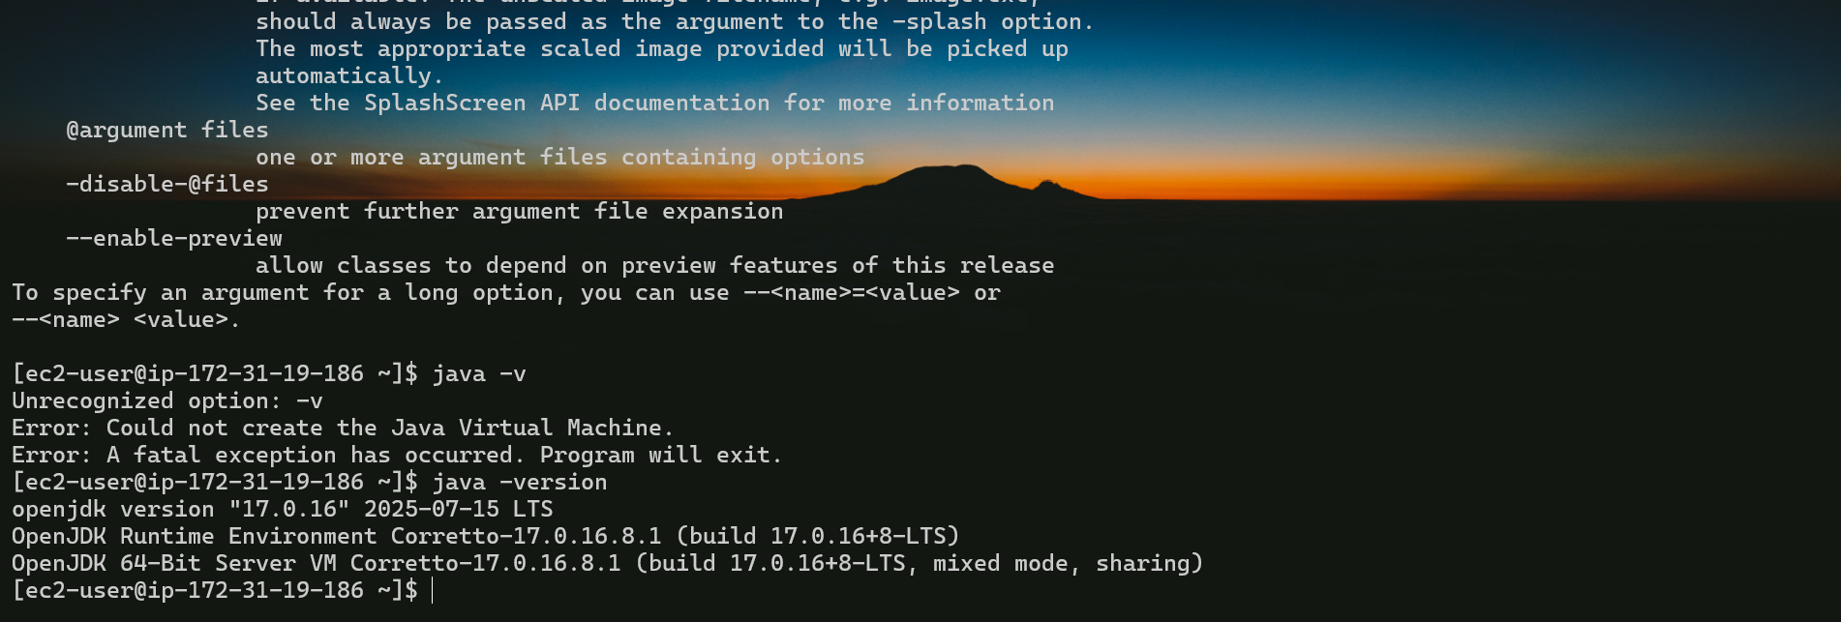

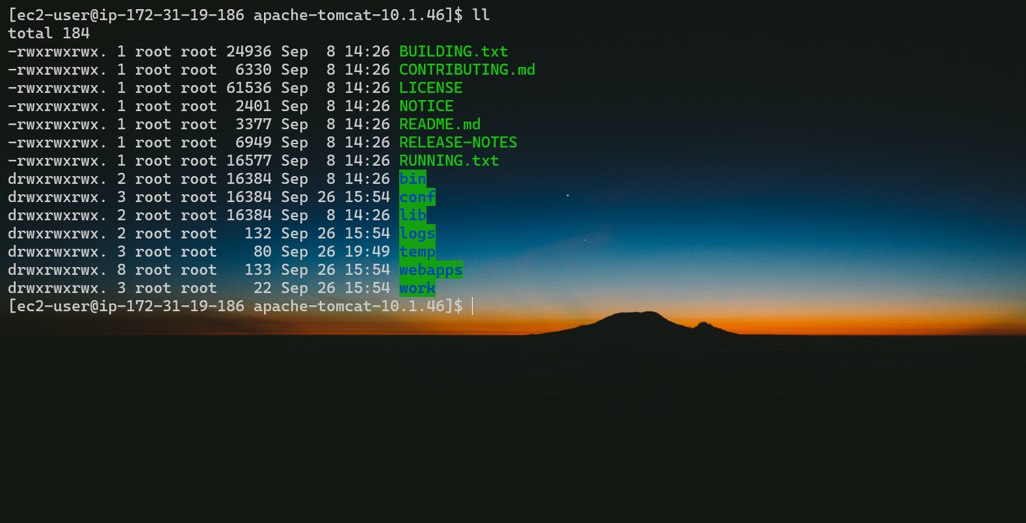

Step -2 install Jenkins as War from official website [copy the war and wget the war file in terminal in webapps folder the switch to bin folder and start the startup script ]

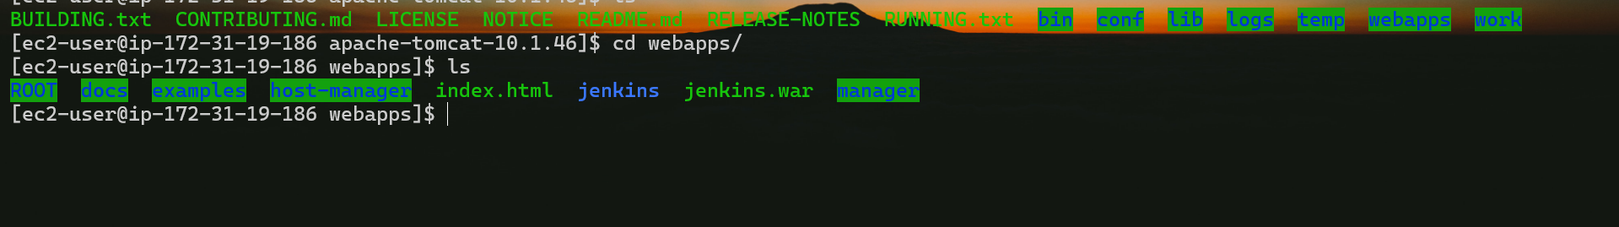

Step -3 The Jenkins will be running hit the ec2-public-ip:8080/Jenkins it will show the Jenkins dashboard

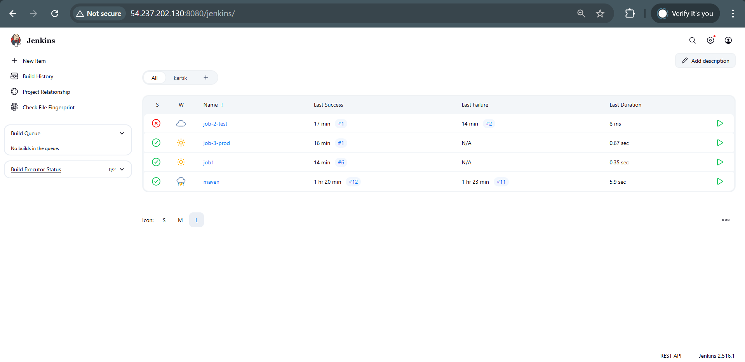

Step -4 create a freestyle job and configure it

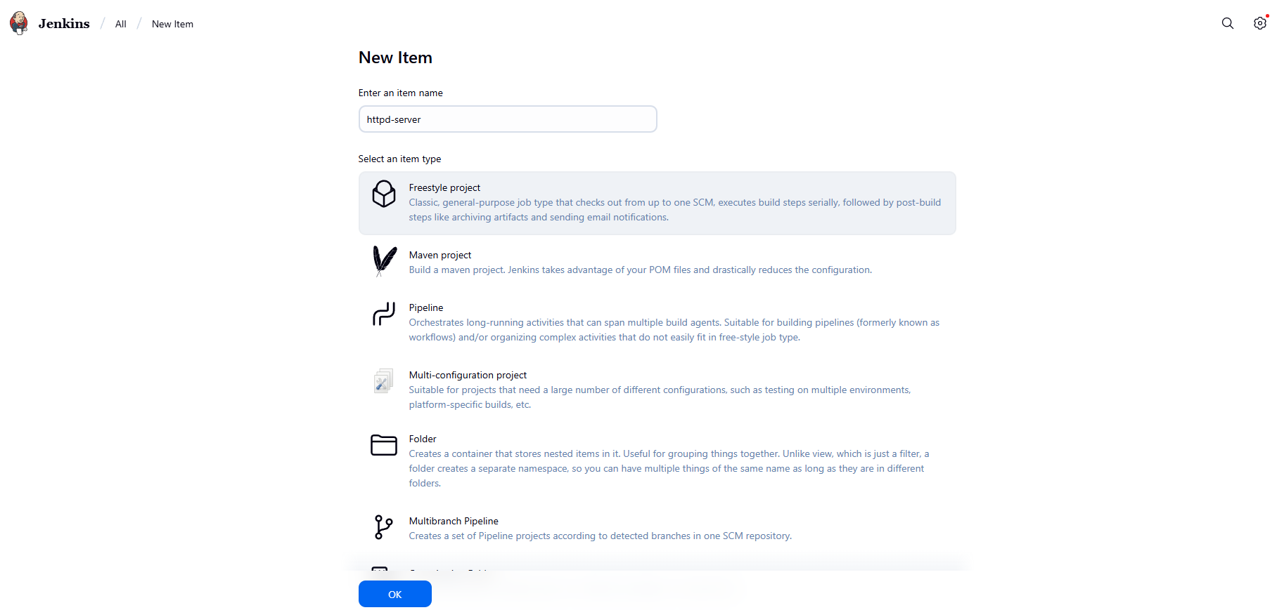

Step -5

Configure the job and the discard build option then select SCM to None the select build step in that execute shell option and write the script

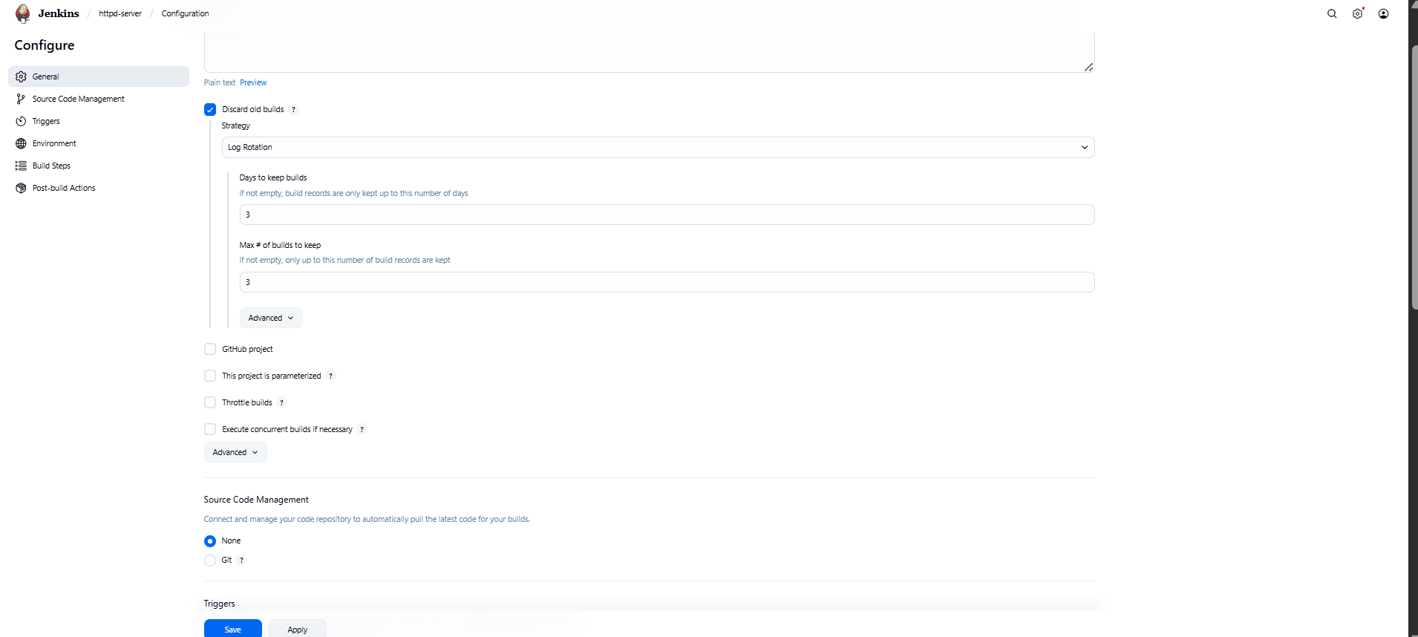

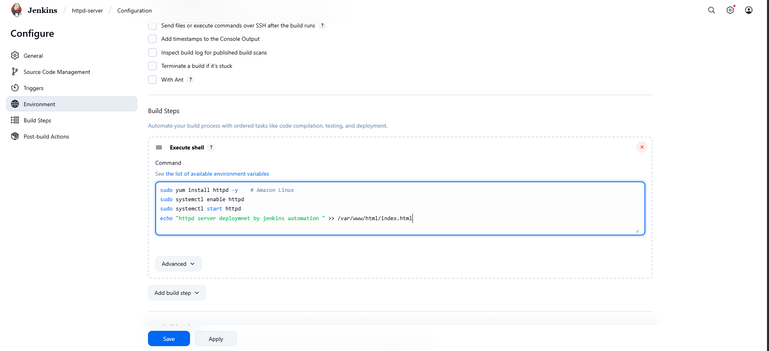

Step -6 Apply and save the job . Run the build you will get the console output

